Cornerstone News
October 2016
Welcome

Welcome to this edition of Cornerstone news. This newsletter is incredibly important for you as we begin to understand the strategic plan that Cornerstone is seeking to implement without any attempt at meaningful negotiation with UNISON.

Please take time to read this newsletter and share with colleagues who we would ask you to encourage to join UNISON now as Cornerstone embarks on this period of change!
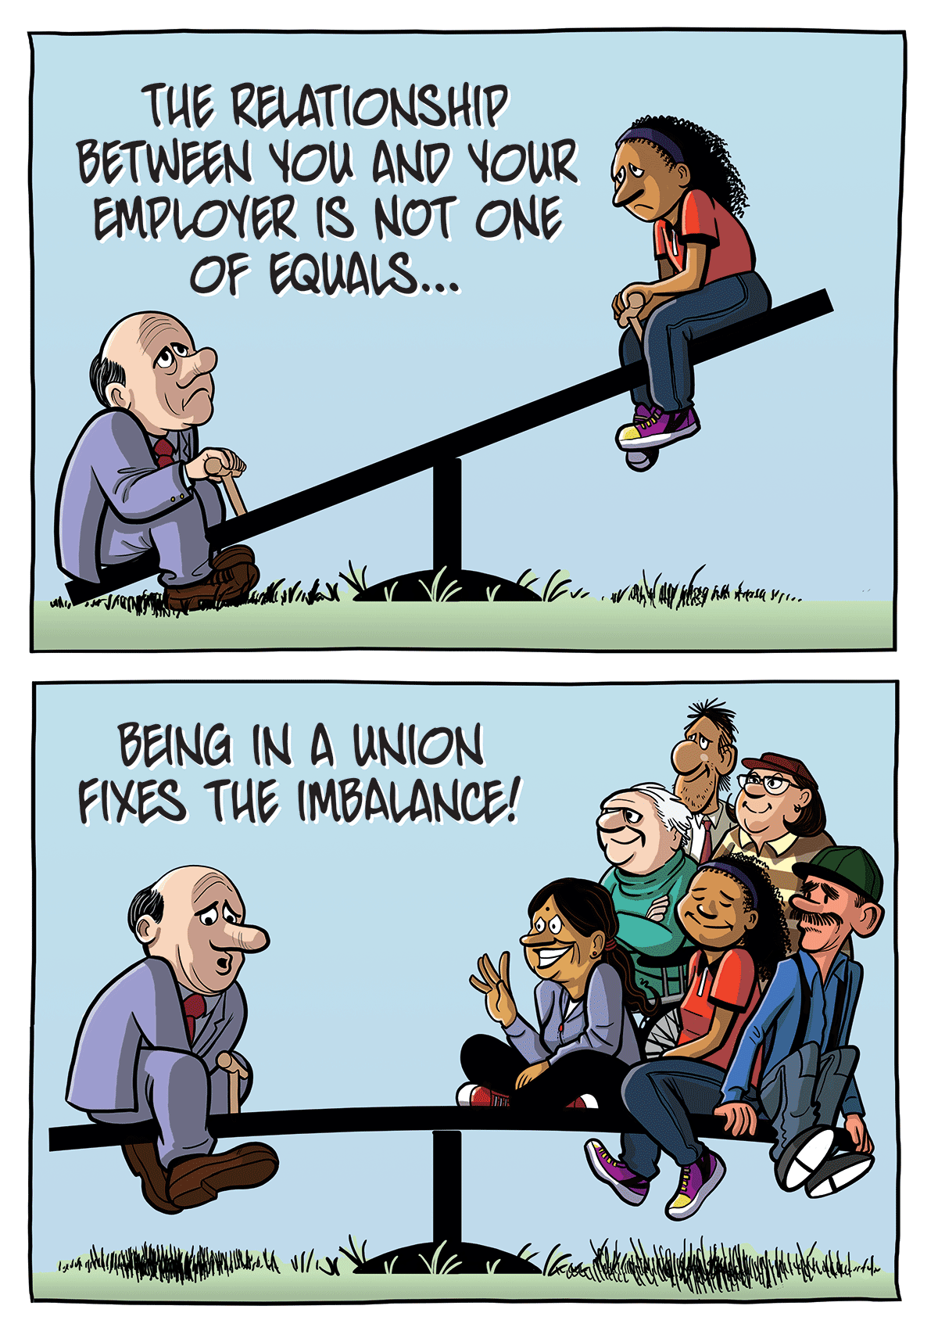
Local Cornerstone
UNISON welcomes the key principles of Local Cornerstone and would wish to work collaboratively on your behalf on such a project that has the potential to deliver ground breaking change for you the staff, the people you support and the wider care sector.
From the little we know Local Cornerstone sets out a number of ambitious key objectives that have the potential for significant changes to staff numbers and roles, pay, terms and conditions and ways of working.
UNISON has only in the last few weeks been “told” of the high level impact for all staff across Cornerstone. We have not been invited to be a part of the formative process and indeed those selected to be involved were asked to sign a confidentiality agreement – which meant they could not discuss the project with either their trade union or colleagues! To our knowledge and more alarmingly no frontline staff appear to have been involved at any stage and this is causing grave concern as they seek to move through imposition to the next stage.

We await comprehensive details of the strategic plan which is being approved by the board. We understand that the detailed strategic plan will be shared at the road shows taking place throughout November.
UNISON has a fundamental difference of opinion with Cornerstone about how this plan is being taken forward, not least because it is being imposed unlawfully without negotiation with UNISON. Right across the UK employers in Local Government, Health and the Third Sector are exploring new and innovative ways of working and that is being undertaken in full consultation and negotiation with partner Trade Unions so Cornerstone’s approach is unique!
Deborah Dyer UNISON’s Head of Community says;
“We are disappointed at Cornerstone’s approach to this potentially ground-breaking project. Success will be wholly dependent on our members continuing to deliver exceptional service to the people they support. We are urging Cornerstone senior management to commence meaningful negotiations at the earliest opportunity. To approach a service redesign on this scale requires all staff to be on board and Cornerstone has a duty to provide staff with the framework, tools and support to continue to deliver that exceptional service. Cornerstone appears to be choosing a very different approach in complete contradiction to its core values.
Change whilst inevitable must always be undertaken collaboratively and with negotiation. Cornerstone has a duty of care to staff and an obligation from funders to demonstrate fair employment practices. Cornerstone has to provide staff with an effective voice and good practice acknowledges this is best achieved through collective agreement with UNISON”
UNISON will not be present at the road shows given our fundamental difference of opinion to the approach being taken by Cornerstone towards its staff. We will, following a meeting with your stewards be arranging a number of UNISON members meetings across Scotland so that you will have an opportunity to raise your concerns. Full details will follow.
We will be in touch again with the dates and hopefully a positive progress report on any response from Cornerstone.
In the meantime we are asking members not to volunteer for imposed new roles and to report back to stewards and UNISON any changes being made to roles and responsibilities.

What is UNISON’s response to these proposals?

While their approach to consultation may be suitable for the employee forum, recognised trade unions have the legal right to meaningful negotiation.

To date Cornerstone management led by the Chief Executive have demonstrated their unwillingness to negotiate around the proposals and instead are intent on only “informing” UNISON of their plans.

We have written formally to Cornerstone to request meaningful consultation under the law at the earliest opportunity. Additionally we will also be writing to the Scottish Government, Local Authorities and other key strategic partners to raise our concerns around the absence of lawful and meaningful consultation.

We will stress our support for the concept and our willingness to work with Cornerstone but share in strong terms our disappointment at the treatment of staff.
We remain hopeful that common sense will prevail and Cornerstone as a good and fair employer with a strong value base will agree to meet with UNISON at the earliest opportunity.
Deborah Dyer
UNISON Head of Community Scotland
Regional Organiser

UNISON Contact Details

Name: Jamie Kelly Tel: 07855 688915 E-Mail: jamiekelly_681@msn.com
Name: Margaret McHenry Tel: 07734 310893 E-Mail: margaret.mchenry@sky.com
Name: Kevin McConnachie Tel: 07833 552675 E-Mail: kvig12@hotmail.co.uk
Name: Brenda Richmond Tel: 07590 504145 E-Mail: giggles.08@live.co.uk

The number one reason for someone not being a member of UNISON is that they have not been asked so please ask a colleague to join UNISON and play a part in building your union today. Join online or use the application overleaf and keep up to date with our UNISON Community Facebook page.

Search for us at: UNISONSCOTCOMMUNITYSEC

