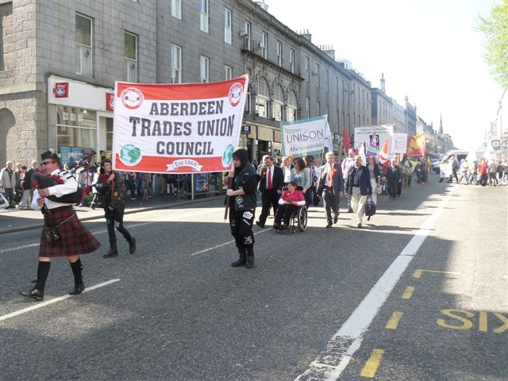 Aberdeen
National Day of Action
Anti-Cuts Rally
Wednesday 30th November 2011 at 12.30pm
at Castlegate

Called by Aberdeen Trades Union Council (ATUC)

Guest speakers (TBC) from various local trade unions, organisations and public service users.

Come join us and support our campaign to save your public services!

